CAS PY 106

InClass Note 30

1. Lens – basic concept
2. Two surface, refraction twice!
3. Surfaces are curved, leading to interesting effects
4. 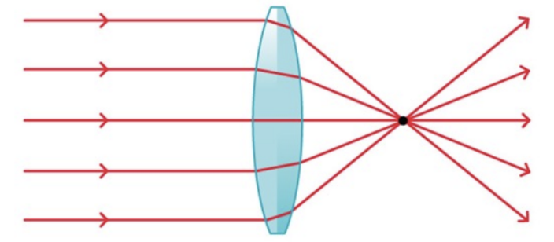
5. Focal point
6. When parallel light comes in, all rays focus on one point: the focal point
7. 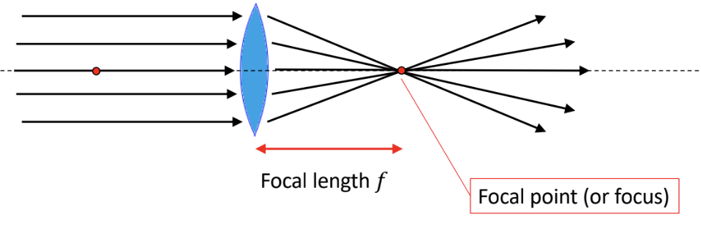
8. Lensmaker’s equation
9. The focal length depends on the radius of curvature
10. 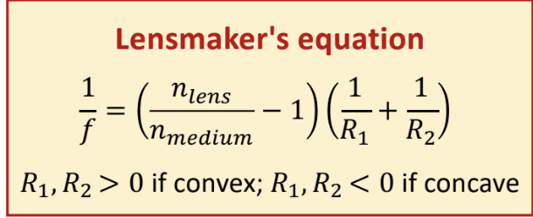
11. 3 special rays
12. Ray 1: comes in parallel with principle axis, goes out through focal point
13. Ray 2: goes through the center of the lends, goes out in same direction
14. Ray 3:: comes in through focal point, goes out parallel with principal axis
15. 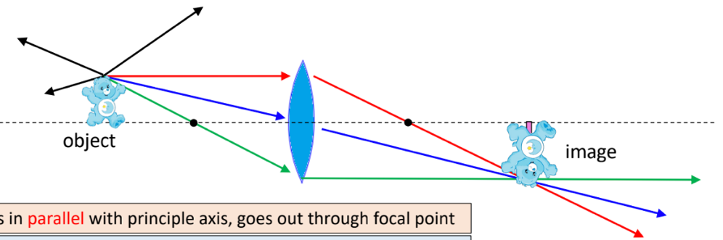
16. What is the correct image distance?
17. 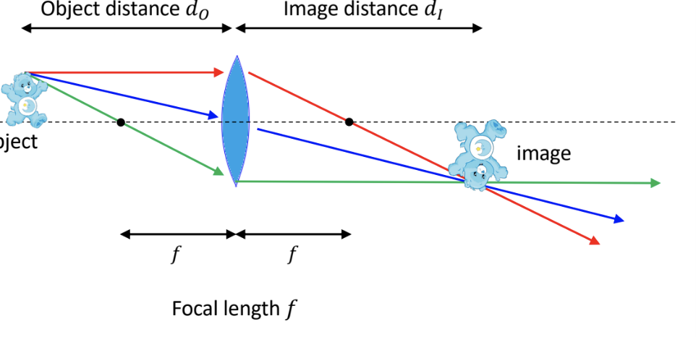
18. 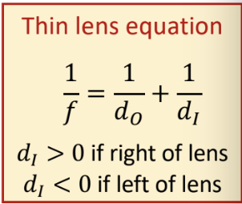
19. 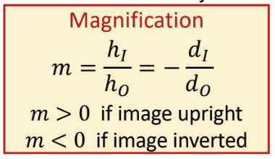
20. Where is my image?
21. 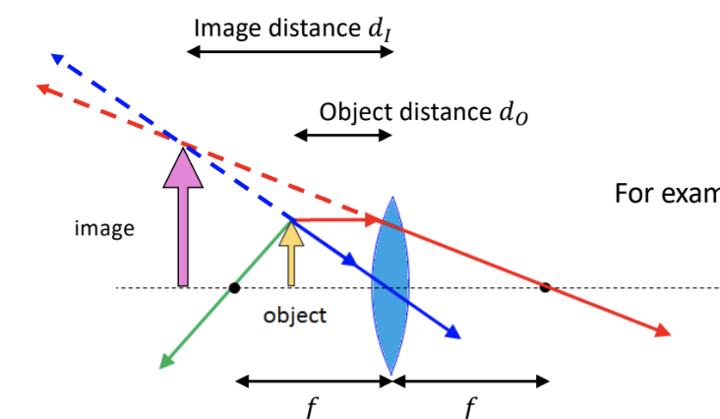
22. How do we find the image for a diverging lens?
23. Ray 1: comes in parallel with principle axis and diverges as if it came out of the focal point
24. Ray 2: goes through the center of the lends, goes out in the same direction
25. Ray 3: directed at the focal point on other side of lends, goes out parallel with principal axis
26. 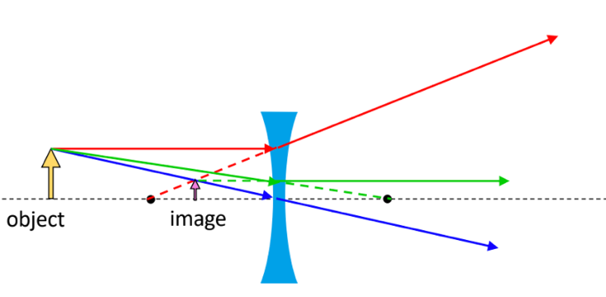
27. Diverging lens example
28. Determine the image distance, magnification, and image height if we know the focal length is -30cm (sign convention for diverging lens is focal length is negative), the object distance is 60cm, and object height is 15cm
29. Image distance = di

1/f = 1/d0 + 1/di

-1/30 = 1/60 + 1/di

-1/30-1/60 = 1/di

-3/60 = 1/di

-1/20 = 1/di

di = -20cm

1. Magnification = m

m = h1/h0 = -di/d0

m = -(-20)/60 = 1/3

1. Image height = hl

m = h1/h0

1/3 = h1/15

h1 = 5cm

1. Sign conventions for lenses
2. 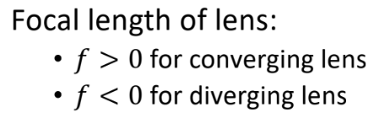
3. 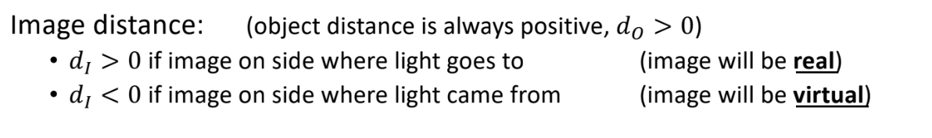
4. 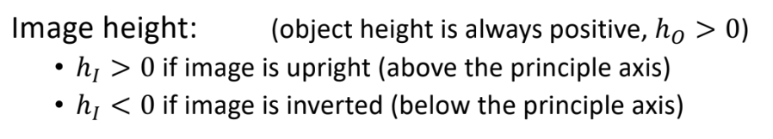
5. Converging lens example 1
6. Determine the image distance, the magnification, and image height if we know the focal length is 30cm (sign convention for converging lens is focal length is positive), the object distance is 75cm, and object height is 15cm
7. Image distance = di

1/f = 1/d0 + 1/di

1/30 = 1/75 + 1/di

1/30 – 1/75 = 1/di

5/150 – 2/150 = 1/di

3/150 = 1/di

di = 50cm

1. Magnification = m

m = -di/d0

= -50/75

= - 2/3

1. Image height = hi

m = hi/h0

-2/3 = hi/15

-10 = hi